Example1:-

**To open an image**

from PIL import Image

ref=Image.open("newfile.jpg")

ref.show()

Output:-

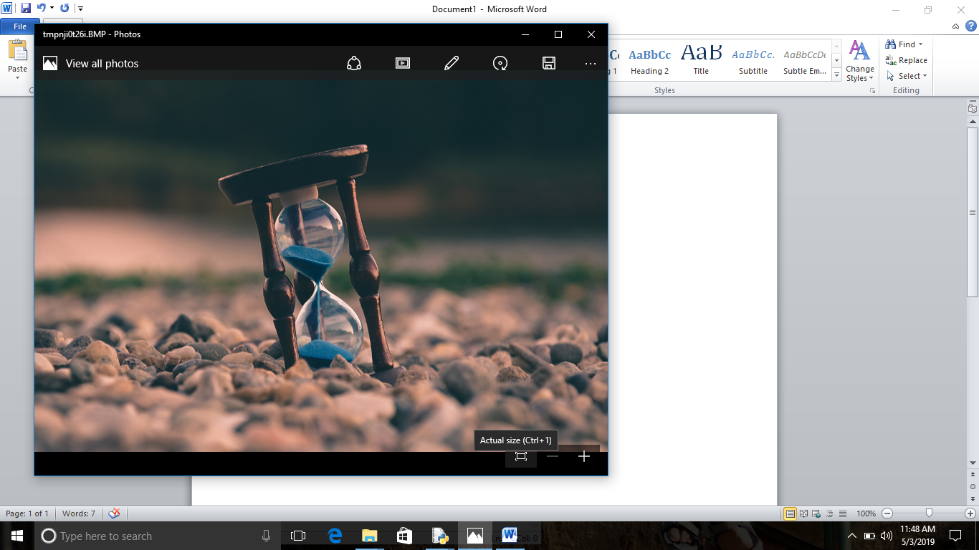

Example2:-

**To open an image and rotate**

**from PIL import Image**

**ref=Image.open("newfile1.jpg")**

**ref1=ref.rotate(90)**

**ref1.show()**

**Output:-**

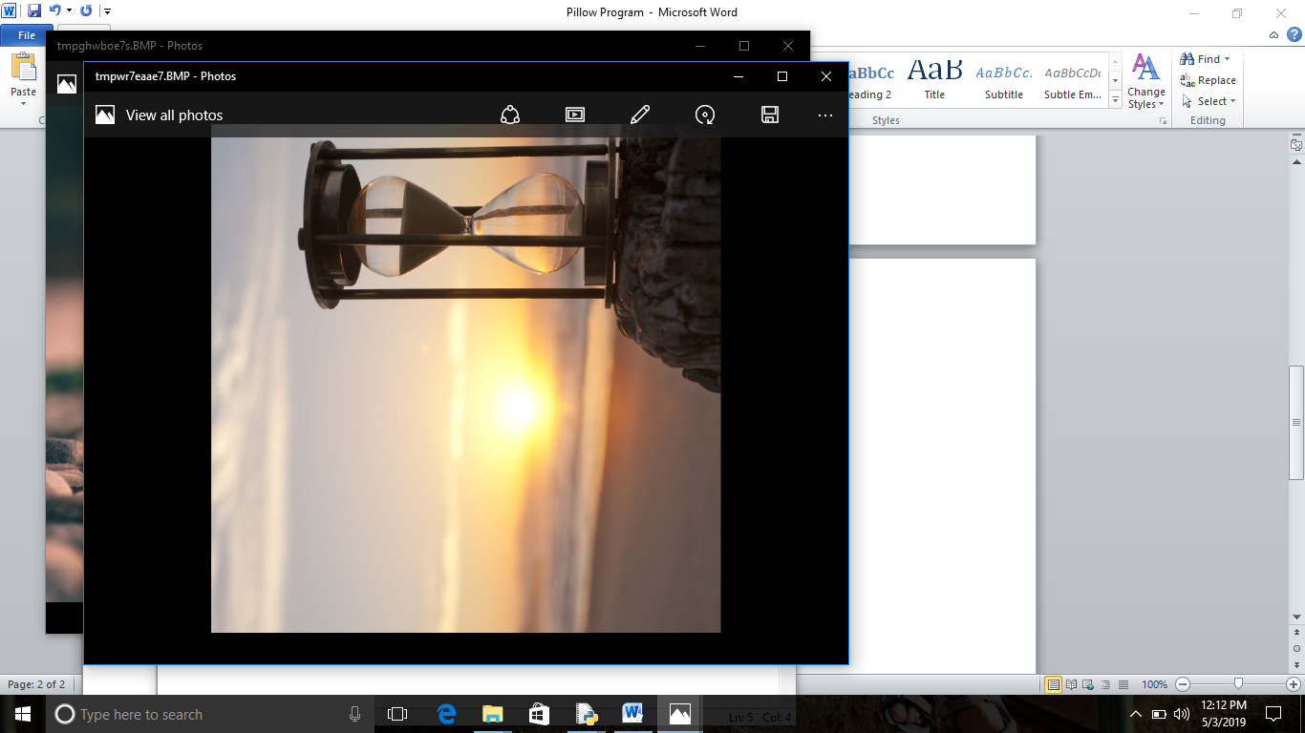

Example3:-

Write a program to display size of image and resize the image.

from PIL import Image

ref=Image.open("newimage.jpg")

ref1=ref.resize((4000,3000))

print(ref1.size)

ref1.show()

ref1.save("newimage.jpg")

**Output:-**

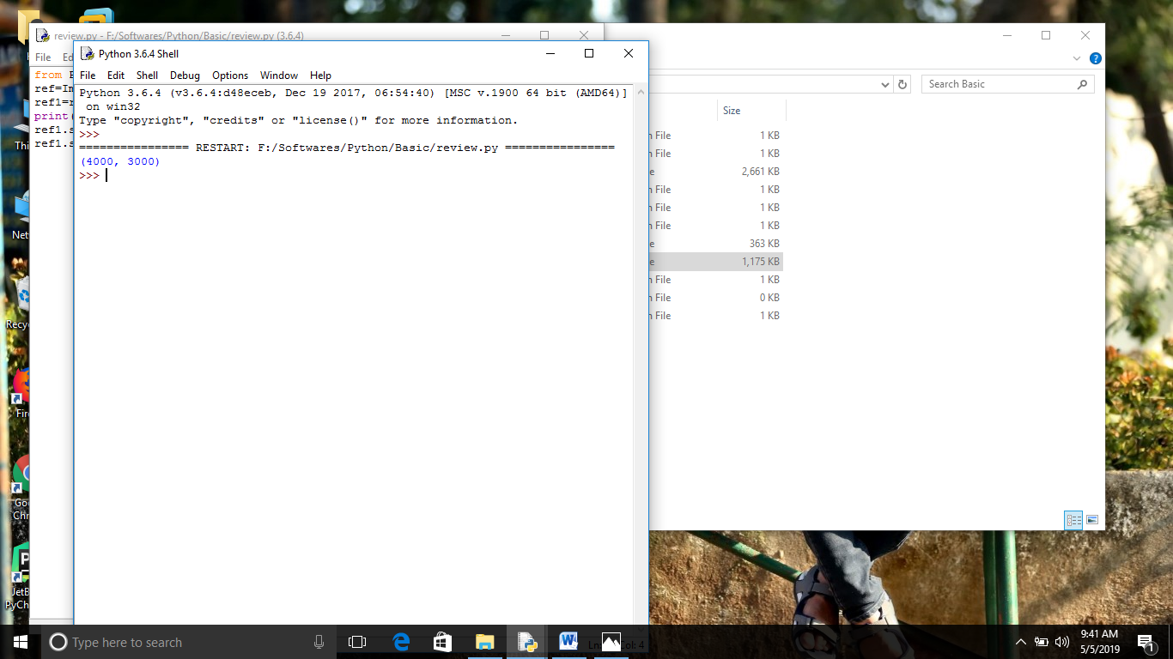

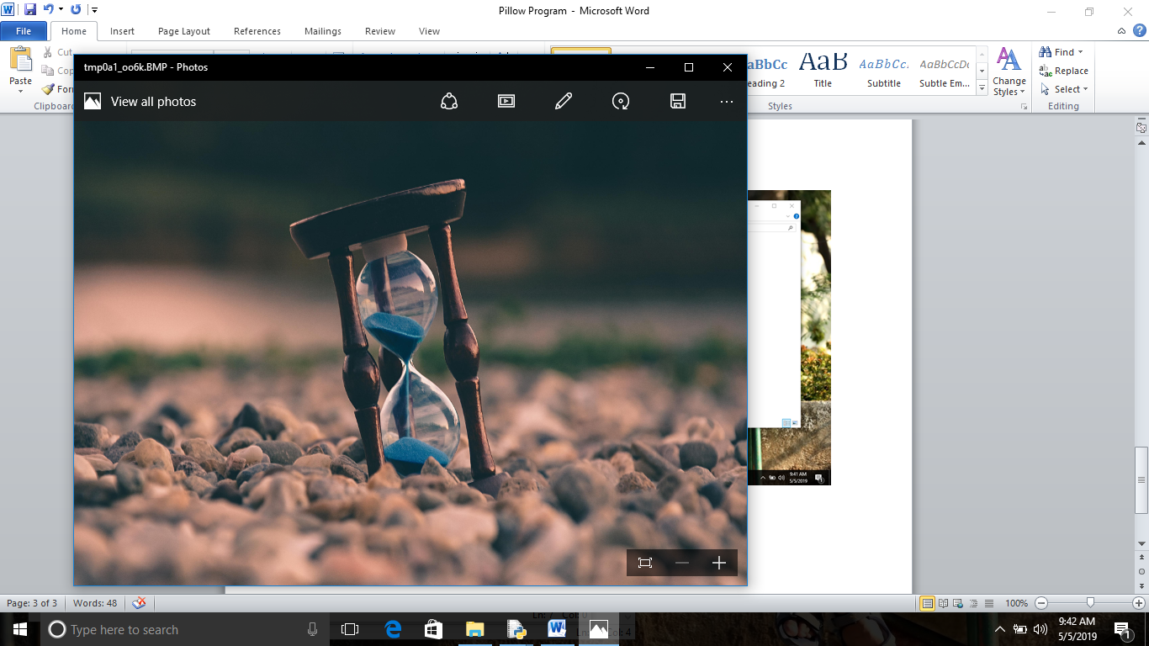

Example 4:-

Write a program to convert Image to Grayscale and display and save.

from PIL import Image

ref=Image.open("newfile1.jpg")

ref1=ref.convert("L")

ref1.show()

ref1.save("newfile.jpg")

**Output:-**

